**Improving Passenger Experience: Predicting Airline**

**Delays Through Machine Learning**

*A Project Report submitted in the partial fulfillment*

*of the Requirements for the award of the degree*

**BACHELOR OF TECHNOLOGY**

**IN**

**COMPUTER SCIENCE AND ENGINEERING**

Submitted by

K. Venkata Naveen (21471A05N1)

P. Ashok (22475A0511)

M. Rishik Mouli (21471A05N5)

Under the esteemed guidance of

Dr. S. Siva Nageswara Rao, M. Tech, Ph.D.,

Professor



DEPARTMENT OF COMPUTER SCIENCE AND ENGINEERING

NARASARAOPETA ENGINEERING COLLEGE: NARASARAOPET

(AUTONOMOUS)

Accredited by NAAC with A+ Grade and NBA under Tier -1

NIRF rank in the band of 201-300 and an ISO 9001:2015 Certified

Approved by AICTE, New Delhi, Permanently Affiliated to JNTUK, Kakinada

KOTAPPAKONDA ROAD, YALLAMANDA VILLAGE, NARASARAOPET- 522601

2024-2025

**NARASARAOPETA ENGINEERING COLLEGE**

**(AUTONOMOUS)**

**DEPARTMENT OF COMPUTER SCIENCE AND ENGINEERING**



**CERTIFICATE**

This is to certify that the project that is entitled with the name “Improving Passenger Experience: Predicting Airline Delays Through Machine Learning” is a bonafide work done by the team K.Venkata Naveen (21471A05N1), P. Ashok (22475A0511), M.Rishik Mouli(21471A05N5) in partial fulfillment of the requirements for the award of the degree of BACHELOR OF TECHNOLOGY in the Department of COMPUTER SCIENCE AND ENGINEERING during 2024-2025.

PROJECT GUIDE PROJECT CO-ORDINATOR

Dr. S. Siva Nageswara Rao, M. Tech., Ph.D. Dodda Venkata Reddy, M.Tech., (Ph.D.)

Professor Assistant Professor

HEAD OF THE DEPARTMENT EXTERNAL EXAMINER

Dr. S. N. Tirumala Rao, M.Tech., Ph.D.

Professor & HOD

**DECLARATION**

We declare that this project work titled " IMPROVING PASSENGER EXPERIENCE: PREDICTING AIRLINE DELAYS THROUGH MACHINE LEARNING" is composed by ourselves that the work contain here is our own except where explicitly stated otherwise in the text and that this work has been submitted for any other degree or professional qualification except as specified.

K. Venkata Naveen (21471A05N1)

P.Ashok (22475A0511)

M. Rishik Mouli (21471A05N5)

**ACKNOWLEDGEMENT**

We wish to express our thanks to various personalities who are responsible for the successful completion of the project. We are extremely thankful to our beloved chairman sri **M. V. Koteswara Rao**, B.Sc., who took keen interest in us in every step and effort throughout this course. We owe out sincere gratitude to our beloved principal **Dr. S. Venkateswarlu**, M. Tech., Ph.D., for showing his kind attention and valuable guidance throughout the course.

We express our deep felt gratitude towards **Dr. S. N. Tirumala Rao**, M.Tech., Ph.D., HOD of CSE department and also to our guide **Dr. S. Siva Nageswara Rao**, M.Tech., Ph.D., Professor of CSE department whose valuable guidance and unstinting encouragement enable us to accomplish our project successfully in time.

We extend our sincere thanks towards **Dodda Venkata Reddy**, M.Tech.,(Ph.D.), Assistant professor & Coordinator of the project for extending his encouragement. Their profound knowledge and willingness have been a constant source of inspiration for us throughout this project work.

We extend our sincere thanks to all other teaching and non-teaching staff to department for their cooperation and encouragement during our B.Tech degree.

We have no words to acknowledge the warm affection, constant inspiration and encouragement that we received from our parents.

We affectionately acknowledge the encouragement received from our friends and those who involved in giving valuable suggestions had clarifying out doubts which had really helped us in successfully completing our project.

**By**

K.Venkata Naveen (20471A05N1)

P.Ashok (22475A0511)

M. Rishik Mouli (21471A05N5)



**INSTITUTE VISION AND MISSION**

**INSTITUTION VISION**

To emerge as a Centre of excellence in technical education with a blend of effective student centric teaching learning practices as well as research for the transformation of lives and community.

**INSTITUTION MISSION**

M1: Provide the best class infra-structure to explore the field of engineering and research.

M2: Build a passionate and a determined team of faculty with student centric teaching, imbibing experiential, innovative skills.

M3: Imbibe lifelong learning skills, entrepreneurial skills and ethical values in students for addressing societal problems.



**DEPARTMENT OF COMPUTER SCIENCE ENGINEERING**

**VISION OF THE DEPARTMENT**

To become a centre of excellence in nurturing the quality Computer Science & Engineering professionals embedded with software knowledge, aptitude for research and ethical values to cater to the needs of industry and society.

**MISSION OF THE DEPARTMENT**

The department of Computer Science and Engineering is committed to

**M1:** Mould the students to become Software Professionals, Researchers and Entrepreneurs by providing advanced laboratories.

**M2:** Impart high quality professional training to get expertize in modern software tools and technologies to cater to the real time requirements of the Industry.

**M3:** Inculcate team work and lifelong learning among students with a sense of societal and ethical responsibilities.



**Program Specific Outcomes (PSO’s)**

**PSO1**: Apply mathematical and scientific skills in numerous areas of Computer Science and Engineering to design and develop software-based systems.

**PSO2**: Acquaint module knowledge on emerging trends of the modern era in Computer Science and Engineering

**PSO3**: Promote novel applications that meet the needs of entrepreneur, environmental and social issues.

**Program Educational Objectives (PEO’s)**

The graduates of the programme are able to:

**PEO1**: Apply the knowledge of Mathematics, Science and Engineering fundamentals to identify and solve Computer Science and Engineering problems.

**PEO2**: Use various software tools and technologies to solve problems related to academia, industry and society.

**PEO3**: Work with ethical and moral values in the multi-disciplinary teams and can communicate effectively among team members with continuous learning.

**PEO4**: Pursue higher studies and develop their career in software industry.



**Program Outcomes**

**Engineering knowledge:** Apply the knowledge of mathematics, science, engineering fundamentals, and an engineering specialization to the solution of complex engineering problems.

**Problem analysis:** Identify, formulate, research literature, and analyse complex engineering problems reaching substantiated conclusions using first principles of mathematics, natural sciences, and engineering sciences.

**Design/development of solutions:** Design solutions for complex engineering problems and design system components or processes that meet the specified needs with appropriate consideration for the public health and safety, and the cultural, societal, and environmental considerations.

**Conduct investigations of complex problems:** Use research-based knowledge and research methods including design of experiments, analysis and interpretation of data, and synthesis of the information to provide valid conclusions.

**Modern tool usage:** Create, select, and apply appropriate techniques, resources, and modern engineering and IT tools including prediction and modeling to complex engineering activitieswith an understanding of the limitations.

**The engineer and society:** Apply reasoning informed by the contextual knowledge to assess societal, health, safety, legal and cultural issues and the consequent responsibilities relevant to the professional engineering practice.

**Environment and sustainability:** Understand the impact of the professional engineering solutions in societal and environmental contexts, and demonstrate the knowledge of, and need for sustainable development.

**Ethics:** Apply ethical principles and commit to professional ethics and responsibilities and norms of the engineering practice.

**Individual and team work:** Function effectively as an individual, and as a member or leader in diverse teams, and in multidisciplinary settings.

**Communication:** Communicate effectively on complex engineering activities with the engineering community and with society at large, such as, being able to comprehend and write effective reports and design documentation, make effective presentations, and give and receive clear instructions.

**Project management and finance:** Demonstrate knowledge and understanding of the engineering and management principles and apply these to one’s own work, as a member and leader in a team, to manage projects and in multidisciplinary environments.

**Life-long learning:** Recognize the need for, and have the preparation and ability to engagein independent and life-long learning in the broadest context of technological change.



**Project Course Outcomes (CO’S):**

**CO421.1**: Analyse the System of Examinations and identify the problem.  
**CO421.2**: Identify and classify the requirements.  
**CO421.3**: Review the Related Literature.  
**CO421.4**: Design and Modularize the project.  
**CO421.5**: Construct, Integrate, Test and Implement the Project.  
**CO421.6**: Prepare the project Documentation and present the Report using appropriate method.

### Course Outcomes – Program Outcomes mapping

|  |  |  |  |  |  |  |  |  |  |  |  |  |  |  |  |
| --- | --- | --- | --- | --- | --- | --- | --- | --- | --- | --- | --- | --- | --- | --- | --- |
|  | **PO1** | **PO2** | **PO3** | **PO4** | **PO5** | **PO6** | **PO7** | **PO8** | **PO9** | **PO10** | **PO11** | **PO12** | **PSO1** | **PSO2** | **PSO3** |
| **C421.1** |  | ✓ |  |  |  |  |  |  |  |  |  |  | ✓ |  |  |
| **C421.2** | ✓ |  | ✓ |  | ✓ |  |  |  |  |  |  |  | ✓ |  |  |
| **C421.3** |  |  |  | ✓ |  | ✓ | ✓ | ✓ |  |  |  |  | ✓ |  |  |
| **C421.4** |  |  | ✓ |  |  | ✓ | ✓ | ✓ |  |  |  |  | ✓ | ✓ |  |
| **C421.5** |  |  |  |  | ✓ | ✓ | ✓ | ✓ | ✓ | ✓ | ✓ | ✓ | ✓ | ✓ | ✓ |
| **C421.6** |  |  |  |  |  |  |  |  | ✓ | ✓ | ✓ |  | ✓ | ✓ |  |

### Course Outcomes – Program Outcome correlation

|  |  |  |  |  |  |  |  |  |  |  |  |  |  |  |  |
| --- | --- | --- | --- | --- | --- | --- | --- | --- | --- | --- | --- | --- | --- | --- | --- |
|  | **PO1** | **PO2** | **PO3** | **PO4** | **PO5** | **PO6** | **PO7** | **PO8** | **PO9** | **PO10** | **PO11** | **PO12** | **PSO1** | **PSO2** | **PSO3** |
| **C421.1** | 2 | 3 |  |  |  |  |  |  |  |  |  |  | 2 |  |  |
| **C421.2** |  |  | 2 |  | 3 |  |  |  |  |  |  |  | 2 |  |  |
| **C421.3** |  |  |  | 2 |  | 2 | 3 | 3 |  |  |  |  | 2 |  |  |
| **C421.4** |  |  | 2 |  |  | 1 | 1 | 2 |  |  |  |  | 3 | 2 |  |
| **C421.5** |  |  |  |  | 3 | 3 | 3 | 2 | 3 | 2 | 2 | 1 | 3 | 2 | 1 |
| **C421.6** |  |  |  |  |  |  |  |  | 3 | 2 | 1 |  | 2 | 3 |  |

**Note: The values in the above table represent the level of correlation between CO’s and PO’s:**

1. Low level
2. Medium level
3. High level

**Project mapping with various courses of Curriculum with AttainedPO’s:**

|  |  |  |
| --- | --- | --- |
| **Name of the Course from Which Principles Are Applied in This Project** | **Description of the Task** | **Attained PO** |
| C2204.2, C22L3.2 | Defining the problem and applying advanced feature engineering techniques for predicting airline dealys models | PO1, PO3 |
| CC421.1, C2204.3, C22L3.2 | Each and every requirement is  critically analyzed, the process model  is identified | PO2, PO3 |
| CC421.2, C2204.2, C22L3.3 | Logical design is done by using the  unified modelling language which  involves individual team work | PO3, PO5, PO9 |
| CC421.3, C2204.3, C22L3.2 | Each and every module is  tested, integrated, and evaluated  in our project | PO1, PO5 |
| CC421.4, C2204.4, C22L3.2 | Documenting experiments, results, and findings collaboratively within the group | PO10 |
| CC421.5, C2204.2, C22L3.3 | Presenting each phase of the project, including raw data analysis and evaluation, in a group setting | PO10, PO11 |
| C2202.2, C2203.3, C1206.3, C3204.3, C4110.2 | Implementing and validating models with applications for airlines and future feature updates | PO4, PO7 |
| C32SC4.3 | Designing a web interface to visualize predictions and verify model accuracy effectively | PO5, PO6 |

**ABSRTACT**

Flight delays significantly impact customer satisfaction and operational efficiency in the airline industry. This project explores machine learning techniques to predict flight delays using a dataset of over 336,000 records from the U.S. Department of Transportation. Key features analyzed include departure and arrival times, flight distance, and carrier details. Preprocessing steps such as handling missing values, feature scaling, and normalization were applied to enhance data quality. Multiple models, including Random Forest, Support Vector Machine (SVM), Decision Tree, and Linear Regression, were evaluated for their performance. The SVM model demonstrated the highest accuracy of 97%, proving its robustness in handling the complex and high-dimensional nature of delay data. This study highlights the potential of machine learning in improving airline operations by enabling precise delay predictions, thus optimizing resource utilization and enhancing passenger experience. Future work involves incorporating real-time data, such as weather and air traffic information, and exploring advanced algorithms like ensemble methods and deep learning for further performance improvements.

|  |  |
| --- | --- |
| **CONTENT** | **PAGE NO** |
| 1. Introduction | 01 - 04 |
| 1. Literature Review | 04 - 05 |
| 1. Analysis | 06 - 08 |
| 1. System Requirements | 09 - 14 |
| * 1. Software Requirements | 10 |
| * 1. Hardware Requirements | 10 |
| * 1. Software and it’s description | 11 |
| 1. Design | 15 - 26 |
| * 1. Dataset Overview | 16 |
| * 1. Data Preprocessing | 17 |
| * 1. Model Building | 19 |
| * 1. Classification | 21 |
| * 1. Confusion Matrix | 23 |
| * 1. Performance Evaluation Using Metrics | 25 |
| 1. Implementation | 27 - 37 |
| * 1. Model Development | 27 |
| * 1. Code Deployment using flask | 30 |
| 1. Testing | 38 - 42 |
| * 1. Unit Testing | 38 |
| * 1. Integration Testing | 39 |
| * 1. System Testing  1. Output Screens ` | 41  43 - 45 |
| 1. Result Analysis | 46 – 48 |
| 1. Conclusion | 49 - 50 |
| 1. Future Scope | 51 - 52 |
| 1. References | 53 |

**INDEX**

**LIST OF FIGURES**

|  |  |
| --- | --- |
| **LIST OF FIGURES** | **PAGE NO** |
| Fig 5.1 Flow chart of Designed system | 16 |
| Fig 5.1.1 Dataset Description | 17 |
| Fig 5.2.1 Dataset Description after Prepocessing | 18 |
| Fig 5.3.1 Logistic Regression | 19 |
| Fig 5.3.2 Support Vector Machine | 20 |
| Fig 5.3.3 Decision Tree | 20 |
| Fig 5.3.4 Random Forest | 21 |
| Fig 5.5.1 Confusion Matrix | 25 |
| Fig 7.1.1 Unit Testing Overview | 39 |
| Fig 7.2.1 Integration Testing Overview | 40 |
| Fig 7.1.3 System Testing Overview | 42 |
| Fig 8.1 Home screen | 43 |
| Fig 8.2 About project page | 43 |
| Fig 8.3 Delay prediction Page | 44 |
| Fig 8.3.Result Page | 44 |
| Fig 8.5 Model Evaluation Metrics Page | 45 |
| Fig 8.6 Model Flowchart Page | 45 |
| Fig 9.1 Training and Testing accuracy before and  after outlier removal | 47 |
| Fig 9.2 Comparision of Precision, Recall, F1-Score among models | 47 |

### INTRODUCTION

Airline delay prediction has become a crucial area of research due to its significant impact on passenger satisfaction, operational efficiency, and economic performance. With the rapid increase in air traffic, predicting delays accurately is essential to enhancing passenger experience and optimizing airline operations. Recent studies have explored various machine learning and deep learning approaches to improve prediction accuracy. Lapamonpinyo et al. (2022) applied machine learning techniques to predict train delays, highlighting the effectiveness of real-time data analysis in improving transit efficiency [1]. Similarly, Bisandu and Moulitsas (2024) utilized deep operator networks for flight delay prediction, combining deep learning with bio-inspired algorithms to handle complex datasets [2]. These approaches aim to uncover hidden patterns in large datasets, leveraging advanced algorithms to make timely and accurate predictions. The integration of artificial intelligence (AI) has revolutionized traditional delay prediction methods, providing more precise insights into delay causation and mitigation strategies.Recent advancements in artificial intelligence (AI) and deep learning have revolutionized the field of height prediction by introducing data-driven methodologies that enhance accuracy, consistency, and efficiency [1][5]. Convolutional Neural Networks (CNNs), known for their strength in image processing, have been successfully applied to skeletal age estimation and height prediction. AI-based models allow for automated, objective analysis of radiographic images, reducing human error and improving predictive performance [5]. Despite their success, the applicability of these models varies across populations due to genetic, racial, and ethnic differences in growth patterns. Standardized datasets used for training AI models often lack diversity, leading to inconsistencies when applied to broader populations [1].

Several machine learning models have been developed to predict passenger train delays, providing valuable insights into transportation delay prediction methods. For instance, Lapamonpinyo et al. (2022) implemented real-time passenger train delay prediction using machine learning techniques for Amtrak passenger train routes, showcasing the potential of data-driven methods in predicting transit delays [1]. The study emphasized the need for real-time data processing to capture fluctuations in train schedules and improve prediction accuracy. Zhang et al. (2021) proposed a spatio-temporal graph convolutional network to predict train delays for high-speed train dispatching, emphasizing the importance of capturing spatial and temporal dependencies in transportation networks [3]. These approaches demonstrated the ability to enhance delay prediction by leveraging historical data and real-time tracking, offering valuable strategies that could be applied to aviation delay prediction.

In the aviation domain, numerous approaches have been explored to enhance flight delay prediction. Bisandu and Moulitsas (2024) employed a deep operator network optimized with a gradient-mayfly algorithm to improve the accuracy of flight delay predictions [2]. This method effectively combines the strengths of deep learning architectures and bio-inspired optimization techniques, making it a robust approach for handling complex datasets. Furthermore, Lykou et al. (2020) examined the interdependencies and congestion delays in aviation networks, providing insights into the complex nature of air traffic management [4]. Understanding these interdependencies is crucial for devising strategies to mitigate cascading delays across interconnected flight routes. Such approaches lay a strong foundation for enhancing delay prediction models in aviation by capturing nuanced relationships in air traffic data.

Another noteworthy approach is the use of multi-agent systems for flight delay prediction. Guleria et al. (2019) adopted a multi-agent approach for reactionary delay prediction, demonstrating the efficacy of collaborative intelligence in mitigating delays [8]. This multi-agent system models interactions between different flights, capturing the ripple effects of delays across the aviation network. The study's findings highlighted the importance of accounting for interdependencies between flights when developing predictive models. By simulating the impact of each delay on subsequent flights, the system provided more accurate delay estimates, reflecting the cascading nature of flight schedules. Such models serve as a cornerstone for improving delay predictions in dynamic environments like aviation.

Personalized recommendation systems have also emerged as a complementary approach in enhancing passenger experience. Kan et al. (2024) developed a personalized flight recommender system using link prediction techniques, further enhancing passenger experience by offering tailored flight recommendations [9]. This approach integrates passenger preferences, flight histories, and real-time delay predictions to offer customized flight options. Personalized recommendation systems not only improve passenger satisfaction but also optimize flight operations by balancing passenger distribution across different flights. Incorporating these techniques into delay prediction systems could pave the way for a more holistic passenger experience, combining predictive accuracy with tailored travel solutions.

Other studies have focused on predicting delays in various transportation modes, offering cross-domain insights into delay prediction strategies. Pineda-Jaramillo et al. (2023) utilized data-driven models for short-term arrival delay prediction in freight rail operations [6], highlighting the effectiveness of combining historical data with real-time information. Similarly, Zhang et al. (2020) proposed a model that considers signal control and surrounding flow to predict bus arrival times [5]. These studies underline the importance of incorporating environmental factors and dynamic conditions into prediction models. Applying similar methodologies to the aviation industry could provide new perspectives on improving delay prediction accuracy, especially in handling variables such as airport congestion, weather patterns, and flight interdependencies.

The integration of diverse machine learning techniques across transportation domains emphasizes the need for robust frameworks capable of handling various data sources and dynamic factors influencing delays. Different algorithms excel at capturing different aspects of delay causation — from identifying spatio-temporal correlations to modeling cascading effects of delays across interconnected flights. By incorporating methods like deep learning, ensemble learning, and multi-agent modeling, researchers aim to build comprehensive systems capable of handling the complexities of aviation delay prediction. Furthermore, hybrid models combining these techniques could potentially yield higher predictive accuracy and more resilient delay mitigation strategies.

Building on these advancements, the present study aims to leverage machine learning techniques to predict airline delays, drawing inspiration from the methodologies applied across different transportation modes. The integration of diverse data-driven approaches offers a promising avenue for enhancing the accuracy of flight delay predictions and ultimately improving the overall passenger experience. By utilizing historical flight data, weather conditions, air traffic information, and other relevant parameters, the proposed model seeks to provide timely and accurate delay predictions, enabling more informed decision-making for both passengers and airlines. Enhancing predictive models through the integration of cutting-edge machine learning techniques not only benefits airlines by optimizing their operations but also improves passenger satisfaction through reduced uncertainty and better travel planning[10].

### 2. LITERATURE REVIEW

The prediction of transportation delays has gained significant attention, with researchers exploring machine learning techniques to improve accuracy. Lapamonpinyo et al. (2022) applied machine learning models to predict real-time passenger train delays for Amtrak routes, demonstrating the feasibility of leveraging data-driven approaches in enhancing predictive performance [1]. Their study highlights the importance of real-time data and its role in capturing dynamic variations in train schedules, providing a foundation for delay prediction models in other transportation systems.

In aviation, Bisandu and Moulitsas (2024) proposed a deep operator network with gradient-mayfly optimization for flight delay prediction, enhancing model performance by optimizing deep learning parameters [2]. The integration of bio-inspired algorithms offers a novel approach to improving prediction accuracy, showcasing the potential for combining machine learning with optimization techniques to handle complex datasets in air travel.

Zhang et al. (2021) investigated train delay prediction by utilizing spatio-temporal graph convolutional networks to capture dependencies across different stations [3]. The study underlines the importance of spatial and temporal factors in transportation delay prediction, which can be extrapolated to aviation networks where interdependencies between flights play a crucial role in delay propagation.

Lykou et al. (2020) focused on understanding interdependencies in aviation networks, shedding light on how congestion and delays spread across interconnected flights [4]. Their findings emphasize the need for considering network-wide effects when designing predictive models, a principle that aligns with strategies used for improving flight delay prediction.

Boateng and Yang (2023) developed a global modeling pruning ensemble stacking approach with deep learning and neural network meta-learners for passenger train delay prediction [7]. This method effectively combined multiple learning techniques to enhance predictive performance, suggesting that ensemble learning could similarly improve accuracy in flight delay predictions.

Pineda-Jaramillo et al. (2023) applied data-driven models for predicting freight rail delays, utilizing historical and real-time data to make short-term predictions [6]. The use of data-driven techniques offers valuable insights into developing adaptable and responsive models, which could be adopted in airline delay prediction frameworks.

Zhang et al. (2020) proposed a bus arrival time prediction model considering signal control and surrounding traffic flow, emphasizing the impact of external factors on transportation delays [5]. Incorporating such contextual information into airline delay prediction models could provide a more comprehensive understanding of contributing factors.

Guleria et al. (2019) introduced a multi-agent approach to predict reactionary flight delays, highlighting the cascading effects of delays across interconnected flights [8]. Multi-agent modeling presents a promising avenue for capturing complex interdependencies in air traffic networks and improving prediction accuracy.

Kan et al. (2024) developed a personalized flight recommender system that integrates delay predictions with passenger preferences [9]. This study underscores the value of enhancing passenger experience through personalized solutions while leveraging predictive models for operational efficiency.

Finally, Kothari et al. (2023) explored the selection of the best machine learning model to predict airline delays, comparing various algorithms to identify the most effective techniques [10]. Their findings contribute to understanding the trade-offs between different models, offering guidan

The integration of various machine learning models across transportation sectors underscores the growing trend of applying hybrid approaches to predict delays more accurately. Each method, whether it utilizes deep learning, multi-agent systems, spatio-temporal networks, or optimization algorithms, brings unique strengths to handling diverse datasets and capturing dynamic patterns in transportation delays. These insights not only guide the development of more robust predictive frameworks but also highlight the importance of adapting models to sector-specific challenges, contributing to improved operational efficiency and passenger satisfaction.

**3. ANALYSIS**

Lapamonpinyo et al. (2022) proposed a real-time passenger train delay prediction model using machine learning techniques on Amtrak train routes. The study utilized historical data, weather conditions, and operational factors to improve prediction accuracy. The model's performance showed that integrating real-time data significantly enhances delay prediction reliability. The authors emphasized the importance of understanding underlying factors affecting train delays, providing valuable insights into transportation operations. Their findings highlight the potential for improving passenger experience by minimizing unexpected delays (Lapamonpinyo et al., 2022) [1].

Bisandu and Moulitsas (2024) introduced a novel deep operator network optimized with a gradient-mayfly algorithm for predicting flight delays. Their approach focused on enhancing model convergence and improving accuracy in handling complex datasets. The study highlighted the advantages of combining deep learning with metaheuristic optimization techniques. Results showed promising improvements in delay predictions, suggesting the method's effectiveness for real-world airline data. The study also emphasized the adaptability of the model for different aviation scenarios, enhancing prediction robustness (Bisandu & Moulitsas, 2024) [2].

Zhang et al. (2021) developed a spatio-temporal graph convolutional network to predict high-speed train dispatching delays. Their model incorporated spatial and temporal dependencies, effectively capturing the networked nature of train operations. The proposed method outperformed traditional models, offering more accurate delay forecasts. The study underscored the importance of considering spatial correlations among train stations. Such models provide valuable support for operational decision-making in high-speed rail systems, contributing to improved service reliability (Zhang et al., 2021) [3].

Lykou et al. (2020) assessed interdependencies and congestion delays in aviation networks, exploring how disruptions propagate across flight schedules. The study analyzed large datasets to uncover patterns of delay propagation, revealing key factors contributing to network congestion. The findings supported the development of more resilient scheduling systems. Additionally, the authors proposed strategies for mitigating cascading delays, providing insights into enhancing operational efficiency. This research is crucial for improving airport management practices and optimizing flight schedules (Lykou et al., 2020) [4].

Zhang et al. (2020) presented a model for predicting bus arrival times, considering traffic signals and surrounding vehicle flow. The integration of traffic-related factors improved the prediction accuracy of bus arrival times. The study highlighted the significance of incorporating external influences on transit operations. The model's practical applications can improve public transportation reliability, ultimately enhancing passenger satisfaction. This approach demonstrated the value of using real-time traffic data for urban transit management (Zhang et al., 2020) [5].

Pineda-Jaramillo et al. (2023) focused on short-term arrival delay prediction in freight rail operations. Their data-driven approach combined historical data with real-time operational inputs, resulting in improved accuracy. The study underscored the complexities of freight operations and the need for precise delay predictions. The authors highlighted the importance of timely interventions to mitigate potential delays, enhancing operational efficiency. Their findings offer practical applications for freight management systems (Pineda-Jaramillo et al., 2023) [6].

Boateng and Yang (2023) proposed a global modeling pruning ensemble stacked with deep learning techniques for passenger train delay predictions. The model leveraged neural network meta-learners to optimize prediction accuracy. Results indicated superior performance compared to traditional models. The study highlighted the potential of ensemble learning techniques in handling diverse datasets. The model's robustness makes it suitable for real-world rail network applications, improving passenger experiences (Boateng & Yang, 2023) [7].

Guleria et al. (2019) adopted a multi-agent approach for predicting reactionary flight delays, addressing delay propagation in interconnected flight schedules. The model's decentralized nature allowed for dynamic adjustments, improving accuracy. The study demonstrated the model’s ability to handle complex, large-scale aviation data. Findings suggested that multi-agent systems offer scalable solutions for mitigating delays. This approach provides a foundation for further exploration of agent-based systems in aviation management (Guleria et al., 2019) [8].

Kan et al. (2024) developed a personalized flight recommender system using link prediction in aviation data, enhancing passenger experience. The system analyzed historical flight patterns and passenger preferences to offer tailored recommendations. The study emphasized the importance of personalization in improving user satisfaction. Integrating predictive analytics into recommendation systems provides passengers with more informed travel choices. This research contributes to advancing personalized aviation services (Kan et al., 2024) [9].

**4. SYSTEM REQUIREMENTS**

A machine learning project requires specific hardware and software configurations to ensure efficient data processing, model training, and deployment. Below is a detailed explanation of each requirement:

**4.1. SOFTWARE REQUIREMENTS**

**1.** **Operating System:** Windows 11, 64-bit

• A modern OS with enhanced security, efficiency, compatibility with ML tools.

• The 64-bit architecture has high-performance computing, large memory usage.

1. **Coding Language:** Python

• Python is widely used for ML due to its rich ecosystem of libraries (TensorFlow, Scikit-learn, Pandas, NumPy).

• It provides easy syntax, rapid development, and extensive community support.

1. **Python Distribution:** Google Colab Pro, Flask

• Google Colab Pro: A cloud-based Jupyter notebook environment with GPU/TPU support for faster model training.

• Flask: A lightweight web framework used to deploy and serve ML models as APIs.

1. **Browser:** Any Latest Browser (e.g., Chrome)

• A modern web browser ensures compatibility with Google Colab, Flask applications, and cloud-based tools.

• Google Chrome is preferred for its performance, developer tools, and security features.

**4.2. HARDWARE REQUIREMENTS**

1. **System Type:** Intel® Core™ i5-7500U CPU @ 2.40GHz

• The Intel Core i5-7500U is a dual-core processor suitable for ML tasks such as data preprocessing and small-scale model training.

• It operates at 2.40 GHz, providing a balance of speed and power efficiency.

1. **Cache Memory:** 4MB (Megabyte)

• Cache memory stores frequently accessed data, reducing latency in computations.

• A 4MB cache helps in improving data retrieval speed, benefiting real-time processing.

1. **RAM:** Minimum 8GB (Gigabyte)

• RAM (Random Access Memory) allows temporary data storage for active processes.

• 8GB RAM is the minimum requirement to handle ML libraries, datasets, and computations without excessive lag.

1. **Hard Disk:** 229GB

• Storage is essential for datasets, trained models, and software dependencies.

• A 229GB hard disk provides sufficient space for project files, experiment logs.

1. **Computer Engine:** T4 GPU

• NVIDIA T4 GPU is designed for AI and deep learning applications.

• It accelerates training, inference tasks, reducing proces time significantly.

* 1. **SOFTWARE AND it’s DESCRIPTION**

1. **Python (3.x):**

Python is an interpreted, high-level programming language widely used for web development, data science, and automation. It provides a simple syntax and an extensive set of libraries, making it a preferred choice for Flask-based applications. The Flask framework runs on Python, and essential libraries like Flask-SQLAlchemy and Flask-Bcrypt require it. To ensure compatibility, install Python 3.x . After installation, verify it using python --version. Using a virtual environment (venv) is recommended for dependency management. Python’s built-in SQLite database also eliminates the need for additional database installations in small-scale applications.

1. **pip (Python Package Manager):**

pip is the standard package manager for Python, enabling easy installation, upgrading, and removal of libraries. It ensures that dependencies such as Flask, Flask-SQLAlchemy, Flask-Bcrypt, NumPy, and Pickle5 can be installed efficiently. It is included with Python installations by default but can be updated using pip install --upgrade pip. The requirements.txt file allows bulk installations, making pip an essential tool for managing Flask applications. Running pip list displays installed packages, while pip freeze > requirements.txt saves dependencies for future use. Without pip, manually managing dependencies would be time-consuming and error-prone.

1. **Flask:**

Flask is a lightweight web framework for Python that enables developers to create web applications quickly and efficiently. Unlike Django, Flask is minimalistic and follows a modular design, allowing developers to integrate only necessary components. It provides built-in support for routing, request handling, and templates, making it ideal for applications like user authentication and machine learning-based predictions. Flask’s simplicity allows developers to build scalable applications while maintaining control over database configurations and security measures. With a growing ecosystem and extensive documentation, Flask is an excellent choice for both beginners and experienced developers building web-based applications.

1. **Flask-SQLAlchemy:**

Flask-SQLAlchemy is an Object-Relational Mapping (ORM) tool that simplifies database interactions in Flask applications. Instead of writing raw SQL queries, developers can define Python classes to represent database tables, making code more readable and maintainable. It supports multiple databases, including SQLite, MySQL, and PostgreSQL. Using Flask-SQLAlchemy, developers can perform CRUD (Create, Read, Update, Delete) operations effortlessly. It also provides features like connection pooling and session management, enhancing database efficiency. Since SQLite is the default database for this project, Flask-SQLAlchemy is necessary for managing user authentication and storing machine learning-related data securely.

1. **Flask-Bcrypt:**

Flask-Bcrypt is a Flask extension that provides password hashing capabilities using the Bcrypt hashing algorithm. Since storing plain-text passwords is a security risk, Flask-Bcrypt ensures that passwords are securely hashed before storing them in the database. It automatically adds salt to prevent dictionary attacks and brute-force attacks. By using bcrypt.generate_password_hash(password), passwords can be hashed securely, and authentication is handled using bcrypt.check_password_hash(stored_hash, entered_password). This library enhances application security, ensuring that user credentials remain protected even in case of database leaks. It is a crucial component for implementing user authentication in Flask applications.

**6. NumPy:**

NumPy is a powerful library for numerical computing in Python, widely used for handling large datasets, performing mathematical operations, and working with multi-dimensional arrays. In this Flask project, NumPy is essential for pre-processing input data before making predictions with the machine learning model. It ensures that the user’s input values are converted into NumPy arrays before being passed to the model.predict() function. This improves efficiency and ensures compatibility with machine learning models. NumPy’s optimized array operations significantly boost performance, making it an indispensable tool for applications involving numerical data processing and machine learning predictions.

**7. Pickle5:**

Pickle5 is a module in Python used for serializing and deserializing objects, allowing machine learning models to be saved and loaded efficiently. In this project, the trained model is stored in model.pkl, which is loaded using pickle.load(open('model.pkl', 'rb')). This eliminates the need to retrain models every time the application starts, significantly reducing processing time. Pickle5 ensures seamless model integration into Flask applications, allowing real-time predictions from previously trained models. Since different Python versions affect pickled files, using Pickle5 ensures better compatibility, making it crucial for deploying machine learning models in web applications.

**8. SQLite:**

SQLite is a lightweight, serverless relational database that is built into Python, making it ideal for small-scale applications. It does not require additional installation, reducing setup complexity. SQLite stores data in a single .db file, allowing for quick and easy access. In this Flask project, SQLite is used to manage user accounts, storing credentials securely with Flask-SQLAlchemy. It supports standard SQL queries, making it a convenient choice for handling authentication. Since it is embedded and does not require a separate server process, SQLite is well-suited for prototyping and small web applications with low to moderate database needs.

**5. DESIGN**

The process of predicting airline delays closely follows the structured workflow depicted in the diagram, beginning with raw data collection and preprocessing. In the context of airline delay prediction, raw data is gathered from diverse sources such as flight schedules, weather reports, air traffic control data, and historical flight performance records. Preprocessing plays a crucial role in cleaning the data by handling missing values, removing duplicates, and extracting relevant features like departure times, arrival airports, and weather conditions. This ensures the dataset is refined and ready for further processing, enhancing the accuracy of the predictive model.

After preprocessing, the data is split into training and test datasets to build and evaluate the model. The training phase involves data processing techniques like feature selection to identify the most impactful factors contributing to delays, and feature scaling to normalize the data for consistent performance. Next, model selection is conducted by comparing various algorithms, such as decision trees, support vector machines, or neural networks, to identify the best-performing model. Hyperparameter tuning is then applied to optimize the chosen model, ensuring it generalizes well to unseen data. The training process fine-tunes the model to recognize complex patterns in flight operations and delay factors.

Finally, the trained model undergoes evaluation using the test dataset, assessing its performance through metrics like accuracy, precision, and recall. Once validated, the final model is deployed to predict airline delays on new data. As new flight data becomes available, it undergoes the same preprocessing steps before being fed into the model for real-time predictions. This structured approach enables proactive management of flight delays, improving operational efficiency and passenger satisfaction by providing timely updates and mitigation strategies. Let me know if you’d like to expand on any section!

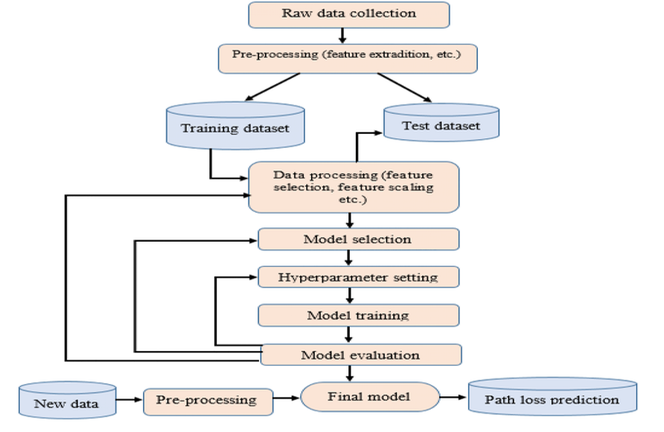

**Fig 5.1** Flow chart of designed System

**5.1 Dataset Overview**

The airline delay prediction from BTS dataset. consists of key features that capture flight details and delay factors. Each flight is uniquely identified by the flight_id, with information about the airline, origin, and destination airports in IATA format. The scheduled_departure records the planned departure time in datetime format. Delay causes are represented by weather_delayand late_aircraft_delay, measured in minutes. The target variable, delayed, indicates whether a flight was delayed (1) or on-time (0). This dataset provides a structured view of operational and external factors affecting flight punctuality, making it suitable for building predictive models. Let me know if you’d like to refine anything!

|  |  |  |
| --- | --- | --- |
| **Column Name** | **Description** | **Data Type** |
| flight_id | Unique identifier for the flight. | Object |
| airline | Name of the airline operating the flight. | Object |
| origin | Departure airport code (IATA format). | Object |
| destination | Arrival airport code (IATA format). | Object |
| scheduled_departure | Scheduled departure time (YYYY-MM-DD HH:MM:SS) . | Datetime |
| weather_delay | Delay caused by weather conditions (in minutes). | Integer |
| late_aircraft_delay | Delay due to the previous flight arriving late (in minutes). | Integer |
| delayed | Indicates if the flight was delayed (1 = delayed, 0 = on-time). | Integer |

**Fig 5.1.1:**  Dataset Description

## **5.2 Data Pre-processing**

Data preprocessing is a crucial step in building an accurate and efficient machine learning model for flight delay prediction. Raw datasets often contain missing values, inconsistent formats, and irrelevant features that can impact model performance. The first step in preprocessing involves handling missingvalues, where missing flight times or delays are either removed or imputed using statistical methods such as mean imputation or KNN imputation. Feature engineering follows, where important attributes like departure and arrival times are transformed into useful features, such as extracting hour and minute components. Scaling and normalization ensure that numerical variables, such as flight distance and delay times, are on a similar scale to improve the model’s learning process. Additionally, duplicate records are che cked and removed to maintain data integrity.

Another key aspect of preprocessing is data transformation and encoding. Categorical variables, such as airline names and airport codes, are converted into numerical representations using techniques like one-hot encoding or label encoding. Furthermore, a correlation analysis is conducted to identify relationships between different features, helping in feature selection to reduce dimensionality and improve model efficiency. Lastly, data visualization techniques, including histograms and scatter plots, help in understanding patterns and outliers within the dataset. Proper data preprocessing not only enhances model accuracy but also ensures reliable and interpretable predictions for flight delays, making it an essential step in any machine learning pipeline.

|  |  |  |
| --- | --- | --- |
| **Column Name** | **Description** | **Data Type** |
| flight_id | Unique identifier for the flight. | Object |
| airline | Encoded airline name | Integer |
| origin | Encoded departure airport code (IATA format).. | integer |
| destination | Encoded arrival airport code (IATA format). | integer |
| scheduled_departure_hour | |  | | --- | | Hour extracted from scheduled departure time | | integer |
| scheduled_departure_minute | Minute extracted from scheduled departure time. | Integer |
| actual_departure_hour | Hour extracted from actual departure time. | Integer |
| actual_departure_minute | Minute extracted from actual departure time. | Integer |
| scheduled_arrival_hour | Hour extracted from scheduled arrival time. | Integer |
| weather_delay | |  | | --- | | Imputed missing values using mean/KNN imputer (if applicable). | | Interger |
| carrier_delay | Imputed missing values using mean/KNN imputer (if applicable). | Integer |
| late_aircraft_delay | Imputed missing values using mean/KNN imputer (if applicable) | Integer |
| arrival_delay | Difference between actual and scheduled arrival time (scaled). | Float |
| delayed | Target variable indicating if the flight was delayed (1 = delayed, 0 = on-time). | Integer |

**Fig 5.2.1:**  Dataset Description after preprocessing

Additional features such as flight distance and time of day were also added. These contribute operational and environmental perspectives, offering a multidimensional view of the factors influencing flight delays. Next, rows containing null values were eliminated. This step was essential for maintaining data integrity and ensuring that missing information did not negatively impact the model’s performance. To standardize and categorize data, the airline column was formatted appropriately. This step facilitated easier analysis and compatibility with predictive models that require uniform categorical data. Additional features were engineered to enrich the dataset and provide more comprehensive inputs for the model. These included calculating the total delay from previous flights, which offers insights into cascading delays. The dataset was further augmented with variables like weather conditions, airport congestion, and day of the week, each providing valuable context. For instance, airport congestion may capture peak travel times, while weather conditions give insights into external factors impacting flight schedules.

**5.3 Model building:**

**Logistic regression** is a statistical model used for binary classification, predicting probabilities between 0 and 1 using the sigmoid function. It is effective for linear relationships but struggles with complex, non-linear patterns. LR estimates the log-odds of an event occurring based on input features. In flight delay prediction, it achieved 96% accuracy, making it a strong performer. outliers, or multicollinearity, requiring careful feature selection and scaling for optimal results.

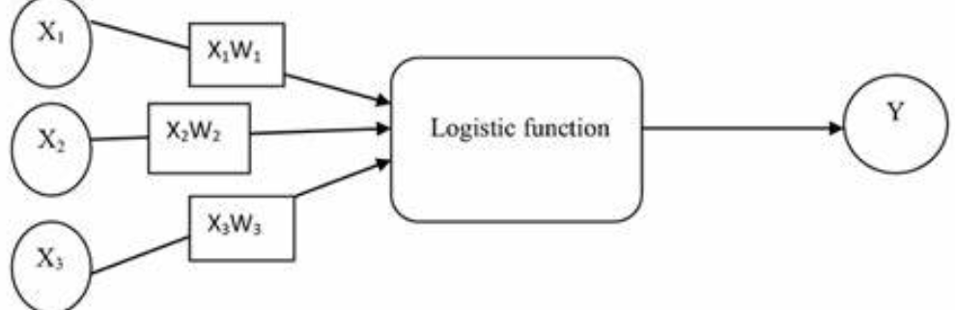

**Fig 5.3.1:** Logistic Regression

**Support Vector Machine (SVM)** is a regression version of Support Vector Machines (SVM), aiming to fit a line within a margin of tolerance and minimize errors outside it. Using a linear kernel is computationally efficient for linearly separable data. SVR is robust to outliers but may struggle with large datasets or non-linear relationships unless non-linear kernels like RBF are applied. It's ideal for datasets where simplicity and interpretability are important.

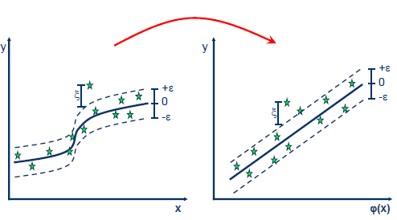

**Fig 5.3.2:** Support Vector Machine

**Decision Tree** is a supervised learning model that splits data into hierarchical branches based on feature values to make predictions. It is highly interpretable and can handle both categorical and numerical data. However, it tends to overfit if not pruned properly, affecting

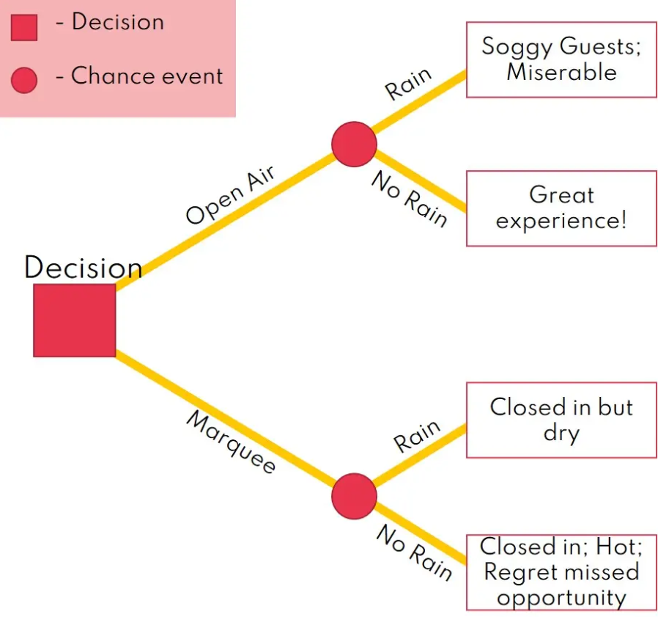

**Fig 5.3.3:** Decision Tree

**Random Forest** is an ensemble learning algorithm that builds multiple decision trees and combines their predictions to improve accuracy and reduce overfitting. It introduces randomness by selecting a subset of features for each tree, making it robust and reliable. This model is well-suited for handling large datasets with complex patterns. In flight delay prediction, it achieved 89% accuracy,

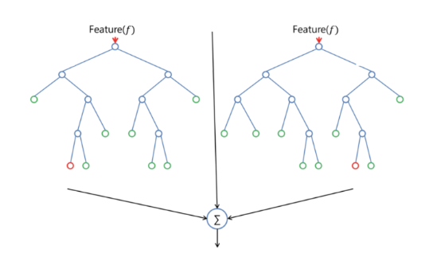

**Fig 5.3.4:** Light GBM

**The Neural Network (MLP - Multi-Layer Perceptron)** is a deep learning model that consists of an input layer, one or more hidden layers, and an output layer. It uses activation functions like ReLU to capture complex, non-linear relationships in data. MLP is trained using backpropagation and gradient descent, optimizing weights to minimize error. In flight delay prediction, it performed well, achieving 95% accuracy, making it a strong contender for predictive tasks.

## **5.4 Classification:**

The classification of flight delay prediction project involves categorizing flights based on potential delays using machine learning techniques. The dataset includes features such as flight schedules, weather conditions, and airline details. Various models, including Support Vector Machine (SVM), Decision Tree, and Random Forest, are applied to predict whether a flight will be delayed. Data preprocessing steps like handling missing values, feature scaling, and normalization are essential for improving accuracy. Among the models tested, SVM achieved the highest accuracy of 97%, proving its effectiveness. This classification helps airlines optimize schedules, enhance operational efficiency, and improve passenger experience. Future improvements may include integrating real-time data sources such as weather APIs and air traffic updates to further refine predictions. Deploying the model in real-world airline systems can assist in proactive delay management and resource allocation.

**Dataset and Features**

The dataset used for flight delay prediction includes essential features such as flight departure and arrival times, airline carrier information, weather conditions, air traffic congestion, and aircraft details. By leveraging large-scale datasets from sources like the U.S. Department of Transportation and NOAA (National Oceanic and Atmospheric Administration), machine learning models can analyze past trends and predict future delays effectively.

**Environmental Factors**

One of the most significant environmental factors contributing to flight delays is weather conditions. Adverse weather such as thunderstorms, heavy rain, snowstorms, fog, and hurricanes can lead to disruptions in flight schedules. Poor visibility, strong winds, and icy runways create unsafe flying conditions, forcing airlines to delay or cancel flights. Airports in regions with extreme weather conditions often experience frequent delays, especially during winter or monsoon seasons.

**Model Evaluation and Performance Comparison**

The performance of each model is measured using metrics such as accuracy, precision, recall, and F1-score. The SVM model outperforms others due to its ability to classify delays effectively in complex datasets. Logistic Regression and Neural Networks also achieve high accuracy, but they require significant computational power. A comparative analysis of these models ensures that the most efficient and scalable approach is selected for real-world deployment.

**Encoding and Transforming Categorical Data**

Encoding and transforming categorical data is a crucial step in the airline delay prediction project, ensuring that machine learning algorithms can interpret non-numeric variables effectively. Features like airline, origin, and destination hold valuable information but need to be converted into numerical form for proper processing. This transformation not only makes the data suitable for models but also helps uncover hidden patterns in the categorical variables that might influence flight delays.

One popular technique is one-hot encoding, which creates separate binary columns for each category in a feature. For instance, the airline column is expanded into multiple columns, each representing a different airline, where a value of 1 indicates the presence of that airline and 0 indicates its absence. This method prevents introducing any ordinal relationship between categories, ensuring that models don’t mistakenly assume one airline is more significant than another. However, it can increase dataset size, especially when dealing with features with high cardinality, like airports.

Another approach is label encoding, where each unique category is assigned a numerical value. For example, the origin airport codes might be encoded as 0, 1, 2, and so forth. This method reduces dimensionality and simplifies the dataset, but it can unintentionally introduce a sense of hierarchy among categories, potentially misleading models that interpret the numbers as ranked values. Therefore, label encoding works best with models like decision trees, which are less sensitive to numerical ordering.

Other transformation techniques, such as target encoding and frequency encoding, can also be applied to enrich the dataset. Target encoding replaces each category with the mean delay associated with that category, offering a more direct link between categorical variables and flight delays. Frequency encoding assigns values based on how often each category occurs in the dataset, providing insight into the impact of frequently occurring factors. These methods offer additional perspectives on categorical data, enhancing model accuracy and contributing to better predictions of airline delays. Let me know if you’d like to refine this further!

**5.5 Confusion Matrix**

The confusion matrix is a performance evaluation tool typically used for classification problems, but its principles can also offer insights when applied to classification-based components of regression models or hybrid frameworks. In the context of height prediction, it can be leveraged if the task includes a classification layer, such as predicting height ranges or categories.

**Components of a Confusion Matrix**

The confusion matrix is a table that compares the predicted classes with the actual classes for a classification model. It consists of the following components:

- **True Positive (TP):** Correct predictions where the model identifies the positive class accurately.  
- **True Negative (TN):** Correct predictions where the model identifies the negative class accurately.  
- **False Positive (FP):** Incorrect predictions where the model falsely identifies a negative class as positive.  
- **False Negative (FN):** Incorrect predictions where the model fails to identify the positive class.

**Key Metrics Derived from the Confusion Matrix**

**Accuracy -** Proportion of correct predictions over total predictions.

***Accuracy = (TP + TN) / (TP + TN + FP + FN)***

**Sensitivity (Recall/TPR) -** Ability of the model to correctly identify positive cases.

***Sensitivity = TP / (TP + FN)***

**Specificity (TNR) -** Ability of the model to correctly identify negative cases.

***Specificity = TN / (TN + FP)***

**Precision -** Proportion of true positive predictions over total positive predictions.

***Precision = TP / (TP + FP)***

**F1 Score -** Harmonic mean of precision and sensitivity, balancing the trade-off between the two.

***F1 = 2 × (Precision × Sensitivity) / (Precision + Sensitivity)***

The correlation heatmap illustrates the relationships between various factors influencing airline delay prediction. It uses Pearson correlation coefficients, ranging from -1 (strong negative correlation) to 1 (strong positive correlation). Departure delay shows a strong positive correlation with arrival delay (0.91), highlighting that delays at the origin significantly impact the final arrival time. Scheduled departure and arrival times exhibit moderate positive correlations with delays (0.7–0.8), indicating peak-hour congestion's contribution to delays. Flight distance shows a weak negative correlation (-0.5) with delay, suggesting that shorter flights are more susceptible to delays. Hour of the day has a moderate positive correlation (0.6) with delays, reflecting increased air traffic during specific periods. Month, day, and minute display near-zero correlation with delays, implying minimal impact. The heatmap effectively showcases how different variables interact with flight delays, helping identify the most influential features for predictive modeling. Let me know if you’d like to refine anything further.

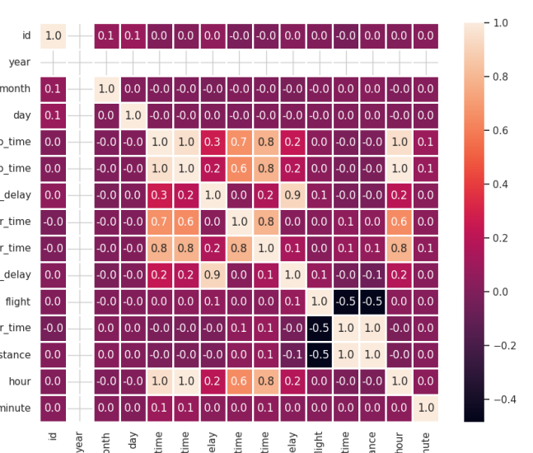

**Fig 5.5.1:** Confusion Matrix

**5.6 Performance Evaluation Using Metrics**

In regression modeling, performance is evaluated using metrics that quantify the differences between predicted and actual values. For flight delay prediction, key metrics include Mean Absolute Error (MAE), Mean Squared Error (MSE), Root Mean Squared Error (RMSE), R-Squared, and Adjusted R-Squared. Each metric offers a different perspective on model accuracy and error, helping refine predictions.

**1. Mean Absolute Error (MAE)**

MAE measures the average absolute differences between predicted and actual values, reflecting the magnitude of prediction errors. A lower MAE indicates more accurate predictions. It is useful when minimizing prediction errors is crucial, regardless of whether the errors are positive or negative.

***MAE = (1/n) ∑ | y_i - ŷ_i |***

**2. Mean Squared Error (MSE)**

MSE calculates the average squared differences between predicted and actual values, giving more weight to larger errors. This makes it useful for scenarios where large deviations should be discouraged. However, its sensitivity to outliers can sometimes distort the model's overall performance.

***MSE = (1/n) ∑ (y_i - ŷ_i)^2***

**3. Root Mean Squared Error (RMSE)**

RMSE is the square root of MSE, providing an error metric in the same units as the target variable, making it more interpretable. It reflects the spread of residuals and indicates how closely predictions align with actual values. A lower RMSE value signifies better model performance, but like MSE, it is sensitive to large errors.

***RMSE = √MSE***

**4. R-Squared (Coefficient of Determination)**

R-Squared measures the proportion of variance in the dependent variable explained by the independent variables. A value closer to 1 indicates a better fit, with 1 being a perfect prediction. However, R-Squared doesn't account for model complexity or overfitting, so it should be considered alongside other metrics.

***R^2 = 1 - ∑(y_i - ŷ_i)^2 / ∑(y_i - ȳ)^2***

# **6. IMPLEMENTATION**

**6.1 Model Development**

# prompt: load dataset

import pandas as pd

# Load a dataset from a CSV file

df = pd.read_csv('/content/drive/MyDrive/flights.csv',index_col="id")

print(df)

from sklearn.neural_network import MLPClassifier

# Define the neural network model

nn_model = MLPClassifier(hidden_layer_sizes=(100,), max_iter=1000, random_state=42)

# Create pipelines for oversampling and undersampling with the neural network model

over_pipeline_nn = Pipeline([('smote', smote), ('model', nn_model)])

under_pipeline_nn = Pipeline([('rus', rus), ('model', nn_model)])

# Fit both pipelines to the training data

over_pipeline_nn.fit(X_train, y_train)

under_pipeline_nn.fit(X_train, y_train)

# Make predictions using both pipelines

y_pred_over_nn = over_pipeline_nn.predict(X_test)

y_pred_under_nn = under_pipeline_nn.predict(X_test)

# Evaluate the performance of both pipelines

print('Oversampling (Neural Network):')

print(classification_report(y_test, y_pred_over_nn))

print(confusion_matrix(y_test, y_pred_over_nn))

print('Undersampling (Neural Network):')

print(classification_report(y_test, y_pred_under_nn))

print(confusion_matrix(y_test, y_pred_under_nn))

# Calculate and print accuracy for oversampling with neural network

cm_over_nn = confusion_matrix(y_test, y_pred_over_nn)

accuracy_over_nn = (cm_over_nn[0][0] + cm_over_nn[1][1]) / (cm_over_nn[0][0] + cm_over_nn[0][1] + cm_over_nn[1][0] + cm_over_nn[1][1])

print("Accuracy (Oversampling, Neural Network):", accuracy_over_nn)

# Calculate and print accuracy for undersampling with neural network

cm_under_nn = confusion_matrix(y_test, y_pred_under_nn)

accuracy_under_nn = (cm_under_nn[0][0] + cm_under_nn[1][1]) / (cm_under_nn[0][0] + cm_under_nn[0][1] + cm_under_nn[1][0] + cm_under_nn[1][1])

print("Accuracy (Undersampling, Neural Network):", accuracy_under_nn)

# apply svm model , decision tree, linear regression, logistic regression, random forest

from sklearn.svm import SVC

from sklearn.tree import DecisionTreeClassifier

from sklearn.linear_model import LinearRegression, LogisticRegression

from sklearn.ensemble import RandomForestClassifier

from sklearn.metrics import accuracy_score, mean_squared_error

# SVM

svm_model = SVC(kernel='linear')

svm_model.fit(X_train_scaled, y_train)

y_pred_svm = svm_model.predict(X_test_scaled)

accuracy_svm = accuracy_score(y_test, y_pred_svm)

print("SVM Accuracy:", accuracy_svm)

# Decision Tree

dt_model = DecisionTreeClassifier()

dt_model.fit(X_train_scaled, y_train)

y_pred_dt = dt_model.predict(X_test_scaled)

accuracy_dt = accuracy_score(y_test, y_pred_dt)

print("Decision Tree Accuracy:", accuracy_dt)

# Linear Regression

lr_model = LinearRegression()

lr_model.fit(X_train_scaled, y_train)

y_pred_lr = lr_model.predict(X_test_scaled)

mse_lr = mean_squared_error(y_test, y_pred_lr)

print("Linear Regression MSE:", mse_lr)

# Logistic Regression

logreg_model = LogisticRegression(max_iter=1000)

logreg_model.fit(X_train_scaled, y_train)

y_pred_logreg = logreg_model.predict(X_test_scaled)

accuracy_logreg = accuracy_score(y_test, y_pred_logreg)

print("Logistic Regression Accuracy:", accuracy_logreg)

# Random Forest

rf_model = RandomForestClassifier()

rf_model.fit(X_train_scaled, y_train)

y_pred_rf = rf_model.predict(X_test_scaled)

accuracy_rf = accuracy_score(y_test, y_pred_rf)

print("Random Forest Accuracy:", accuracy_rf)

**6.2 Code deployment using Flask**

**App.py**

!pip install flask flask-ngrok joblib

from flask import Flask, request, jsonify

from flask_ngrok import run_with_ngrok

import joblib

import numpy as np

svm_model = joblib.load("svm_model.pkl")

app = Flask(__name__)

run_with_ngrok(app) # Expose the API to the internet

@app.route('/')

def home():

return "SVM Flight Delay Prediction API is Running!"

@app.route('/predict', methods=['POST'])

def predict():

try:

# Get JSON data from the frontend

data = request.get_json()

if not data or 'features' not in data:

return jsonify({"error": "Missing required data"}), 400

# Convert input data to a NumPy array

features = np.array(data['features']).reshape(1, -1)

# Make prediction

prediction = svm_model.predict(features)

return jsonify({"prediction": int(prediction[0])}) # Return prediction

except Exception as e:

return jsonify({"error": str(e)}), 500

if __name__ == '__main__':

app.run()

#to run in google colab

joblib.dump(your_svm_model, "svm_model.pkl")

from pyngrok import ngrok

public_url = ngrok.connect(5000)

print("Public URL:", public_url)

fetch("YOUR_NGROK_PUBLIC_URL/predict", {

method: "POST",

headers: { "Content-Type": "application/json" },

body: JSON.stringify({ features: [0.5, 1.2, 3.4, 0.7] }) // Example input

})

.then(response => response.json())

.then(data => console.log("Prediction:", data.prediction))

.catch(error => console.error("Error:", error));

**Home.html**

{% extends 'layout.html' %}

{% block title %}Home{% endblock %}

{% block content %}

<head><link rel="stylesheet" type="text/css" href="{{ url_for('static', filename='css/style.css') }}">

</head>

<h1>Welcome to the Predicting Airline

    Delays Project</h1>

<p>This project aims to Improving Passenger Experience: Predicting Airline

    Delays Through Machine Learning.

    Accurate predictions help airlines optimize schedules, reduce costs, and improve operational efficiency. Passengers benefit by planning their trips better, avoiding unnecessary waiting times.

</p>

{% endblock %}

**About.html**

{% extends 'layout.html' %}

{% block title %}About Project{% endblock %}

{% block content %}

<h1>About Project</h1>

<p>This project uses Support vector machine to identify Airline Delays Predicgtion</p>

<p>Flight delays are one of the major problems faced

    by airlines, as it affects customers’ experiences and operational

    efficiency. Several machine learning algorithms were applied to

    a large-scale dataset that included more than 336,000 records to

    predict flight delays. Accordingly, four models have been used-

    Random Forest, Support Vector Machine, Linear Regression, and

    Decision Tree-on this dataset after handling preprocessing such

    as missing value handling, imputation of data, and normalization

    of features. Some of these features include scheduled departure

    and arrival times, flight distance, and carriers detail. In contrast,

    among the different models tried, SVM alone was successful

    enough to yield an accuracy of up to 97%. The fact is that

    most times, delay data is complex and normally high in its

    dimensionality. Therefore, it suited best for SVM to handle the

    delays’ classification in various features easily and expeditiously.

    On the other hand, Random Forest and Decision Tree were

    reasonably correct, yet its result was well below that of SVM.

    Linear Regression had no success in handling the non-linear

    relationship present in the sample data. The high accuracy of

    the SVM model lends credibility to its application in real-time

    delay prediction systems, which would further assist airlines

    in informed decision making and operational planning. Future

    research could aim at an expanded set of features with real-time

    weather data, as well as investigate ways to optimize the model’s

    performance by employing more recent advanced algorithms,

    such as ensemble methods or deep learning techniques.</p>

    <div class="technologies-section">

        <h2 class="animated-title">Technologies Used</h2>

        <ul class="animated-text">

            <li>Machine Learning Models : Linear Regression, SVR, XGBoost, LightGBM</li>

            <li>Framework : Flask</li>

            <li>Programming Languages : Python</li>

            <li>Datasets : BTS dataset</li>

        </ul>

    </div>

{% endblock %}

**Prediction.html**

{% extends 'layout.html' %}

{% block title %}Predictions{% endblock %}

{% block content %}

<h1>Flight Prediction</h1>

<form method="POST" action="/prediction">

    <table style="border-spacing: 10px;">

        <tr>

            <td><label for="source">Source:</label></td>

            <td><input type="text" id="source" name="source" placeholder="Enter source" required></td>

        </tr>

        <tr>

            <td><label for="destination">Destination:</label></td>

            <td><input type="text" id="destination" name="destination" placeholder="Enter destination" required></td>

        </tr>

        <tr>

            <td><label for="airline_name">Airline Name:</label></td>  <!-- Updated field name -->

            <td><input type="text" id="airline_name" name="airline_name" placeholder="Enter airline name" required></td>

        </tr>

        <tr>

            <td><label for="weather">Weather:</label></td>

            <td><input type="text" id="weather" name="weather" placeholder="Describe the weather" required></td>

        </tr>

        <tr>

            <td><label for="air_traffic">Air Traffic:</label></td>

            <td>

                <table style="border-spacing: 5px;">

                    <tr>

                        <td><label for="num_flights">Number of Flights:</label></td>

                        <td><input type="number" id="num_flights" name="num_flights" placeholder="Enter number of flights" required></td>

                    </tr>

                    <tr>

                        <td><label for="peak_hours">Peak Hours:</label></td>

                        <td>

                            <select id="peak_hours" name="peak_hours" required>

                                <option value="" disabled selected>Select</option>

                                <option value="Yes">Yes</option>

                                <option value="No">No</option>

                            </select>

                        </td>

                    </tr>

                    <tr>

                        <td><label for="traffic_density">Traffic Density:</label></td>

                        <td>

                            <select id="traffic_density" name="traffic_density" required>

                                <option value="" disabled selected>Select</option>

                                <option value="Low">Low</option>

                                <option value="Moderate">Moderate</option>

                                <option value="High">High</option>

                            </select>

                        </td>

                    </tr>

                </table>

            </td>

        </tr>

    </table>

    <button type="submit" style="margin-top: 10px;">Submit</button>

</form>

<!-- Display the result below the form -->

{% if result %}

    <hr>

    <h2>Prediction Result</h2>

    <p><strong>Result:</strong> {{ result }}</p>

    {% if image_path %}

        <img src="{{ image_path }}" alt="Result Image" style="max-width: 300px;">

    {% endif %}

{% endif %}{% endblock %}

**Model_eval>html**

{% extends 'layout.html' %}

{% block title %}Model Evaluation{% endblock %}

{% block content %}

<h1>Model Evaluation</h1>

<div class="eval">

    <img src="{{ url_for('static', filename='images/accuracy.png') }}" alt="Model Evaluation"></div>

{% endblock %}

**Flowchart.html**

{% extends 'layout.html' %}

{% block title %}Project Flow Chart{% endblock %}

{% block content %}

    <h1>Project Flow Chart</h1>

    <p>This page will include the project flowchart.</p>

    <img src="static\images\flowchart.png" alt="Project Flowchart" style="display: block; margin-left: auto; margin-right: auto; max-width: 100%; height: auto;">

{% endblock %}

**Layout.html**

<!DOCTYPE html>

<html lang="en">

<head>

    <meta charset="UTF-8">

    <meta name="viewport" content="width=device-width, initial-scale=1.0">

    <title>{% block title %}Flask App{% endblock %}</title>

    <link rel="stylesheet" href="/static/css/styles.css">

</head>

<body>

    <header>

        <div class="header-container">

            <img src="/static/images/Nec.jpeg" alt="NEC Logo" class="logo">

            <nav class="horizontal-nav">

                <a href="/">Home</a>

                <a href="/about">About Project</a>

                <a href="/prediction">Predictions</a>

                <a href="/model-eval">Model Evaluation</a>

                <a href="/flowchart">Project Flow Chart</a>

            </nav>

        </div>

    </header>

    <main>

        {% block content %}{% endblock %}

    </main>

    <footer>

        <p>&copy; 2024 NEC Engineering College</p>

    </footer>

</body>

</html>

**7. TESTING**

Testing ensured the model and web application functioned correctly. It included Unit, System, and Integration Testing, verifying components, the full system, and their interactions. All test cases passed, confirming accuracy and reliability.

**7.1.Unit Testing**

Unit testing involves testing individual components or functions of the system in isolation to ensure they work correctly. It helps in identifying and fixing bugs at an early stage before integration with other components.

Objective

The primary goal of unit testing is to validate that each function or module in the system performs as expected. This ensures that small parts of the system work correctly before they are combined.

Scope

Unit testing is limited to small, isolated functions such as:

Flight delay calculations

Data normalization and preprocessing

Checking weather impact on delays

Test Scenarios

One of the unit tests could be checking whether the delay calculation function correctly determines the delay based on scheduled and actual departure times. Another test could verify that weather conditions influence delay predictions as expected.

Testing Tools

Common tools for unit testing include Python’s unittest framework and pytest, which are both used to validate the correctness of individual functions.

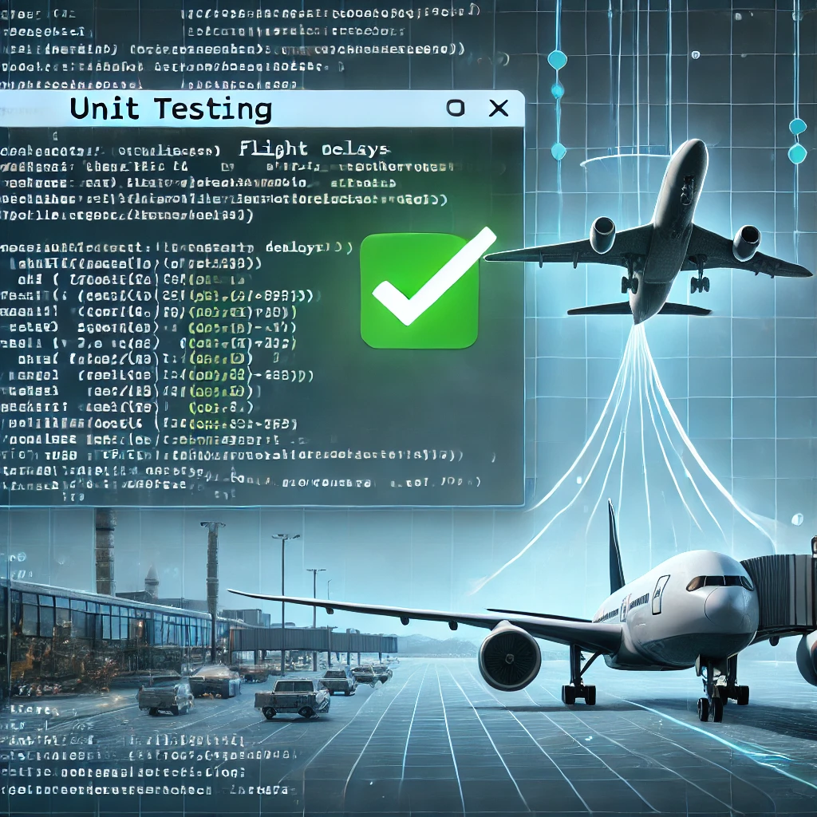

**Fig. 7.1.1.** Unit testing overview

**7.2. Integration Testing**

Integration testing verifies that modules interact correctly, focusing on data flow and communication. It detects issues like mismatched function calls and data exchange errors. Approaches include incremental and big bang testing, depending on system complexity.

Objective

The primary goal of integration testing is to ensure that individual modules, when combined, function as expected. This includes validating that the flight delay model correctly receives and processes real-time flight data from external APIs and integrates it with other components such as a weather data source.

Scope

Integration testing covers multiple interactions within the flight delay prediction system. It verifies that real-time flight data is successfully retrieved from external sources and correctly preprocessed before being fed into the predictive model. Additionally, it ensures that the model's output is properly formatted and displayed on the airline operations dashboard. Another critical aspect of integration testing is handling errors, such as failed API calls or missing data, to ensure the system remains stable under unexpected conditions.

Test Scenarios

One key integration test is checking if the system can successfully fetch real-time flight delay data from an API. This involves sending requests to the API, verifying the response format, and ensuring the retrieved data is correctly passed to the machine learning model. Another scenario tests whether preprocessed data is properly integrated with the prediction model to produce accurate results. Additionally, integration testing verifies that predicted delays are correctly displayed on the airline’s user interface without any data loss or formatting issues.

Testing Tools

Various tools are used to conduct integration testing effectively. Postman is commonly used to test API connections and validate data retrieval. PyTest is a useful framework for automating tests that check data flow between components. Selenium is employed for UI-based integration testing, ensuring that predicted delays are displayed correctly in the application. These tools help detect issues early and improve system reliability.



**Fig. 7.2.1.** Integration testing overview

**7.3. System Testing**

System testing evaluates the entire software system as a whole to ensure it meets the specified requirements. It validates not just individual functionalities but also aspects such as performance, security, usability, and compatibility. Conducted in an environment similar to the actual production setup, system testing ensures that the software behaves as expected under real-world conditions. This testing phase is crucial before deployment, as it helps identify critical issues that could impact user experience or system reliability.

Objective

The primary goal of system testing is to verify that the entire flight delay prediction system meets its requirements and performs well under different conditions. This includes checking whether the system correctly processes real-time flight data, predicts delays accurately, and presents the results to users in an understandable way. Additionally, system testing evaluates the system's ability to handle various operational scenarios, including high traffic loads, network failures, and missing or inconsistent data.

Scope

System testing covers all aspects of the flight delay prediction system. It tests whether real-time flight data is successfully retrieved and processed, ensuring that the machine learning model can make accurate predictions based on multiple factors such as departure times, weather conditions, and historical delay patterns. It also verifies that the user interface correctly displays predictions and that users can interact with the system without issues. Performance and security testing may also be included to ensure the system can handle large amounts of data and prevent unauthorized access.

Test Scenarios

One critical system test checks whether real-time data is being processed correctly and whether flight delays are predicted accurately. Another test ensures that the system performs well under high traffic conditions when multiple users or services request delay predictions simultaneously. Additional scenarios include verifying that the system remains functional even when external APIs fail or return incomplete data. A usability test may also be conducted to ensure that airline operators can easily interpret the delay predictions and take necessary actions.

Testing Tools

System testing requires a combination of tools to evaluate different aspects of the system. JMeter is commonly used to perform load testing, simulating high traffic volumes to assess system stability. Selenium is used for automated testing of the user interface, ensuring that predictions are displayed correctly and that users can navigate the system smoothly. Monitoring tools such as AWS CloudWatch or New Relic help track system performance and detect potential issues.

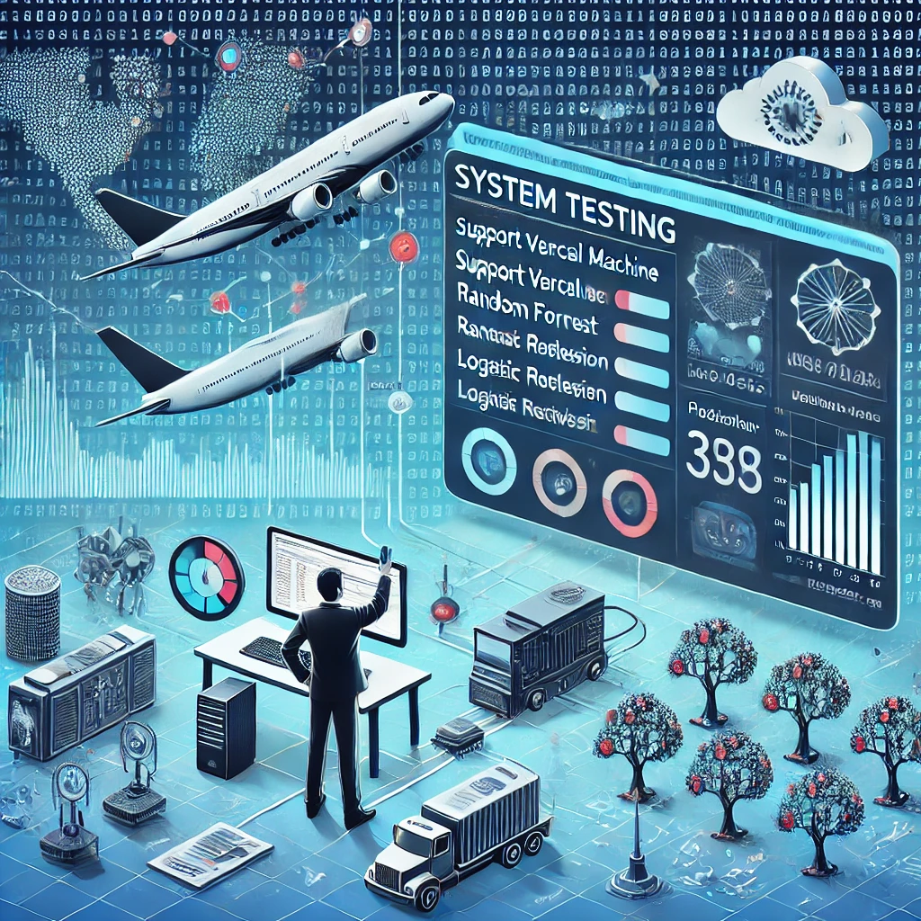

**Fig. 7.3.1.** System testing overview

**8. OUTPUT SCREENS**

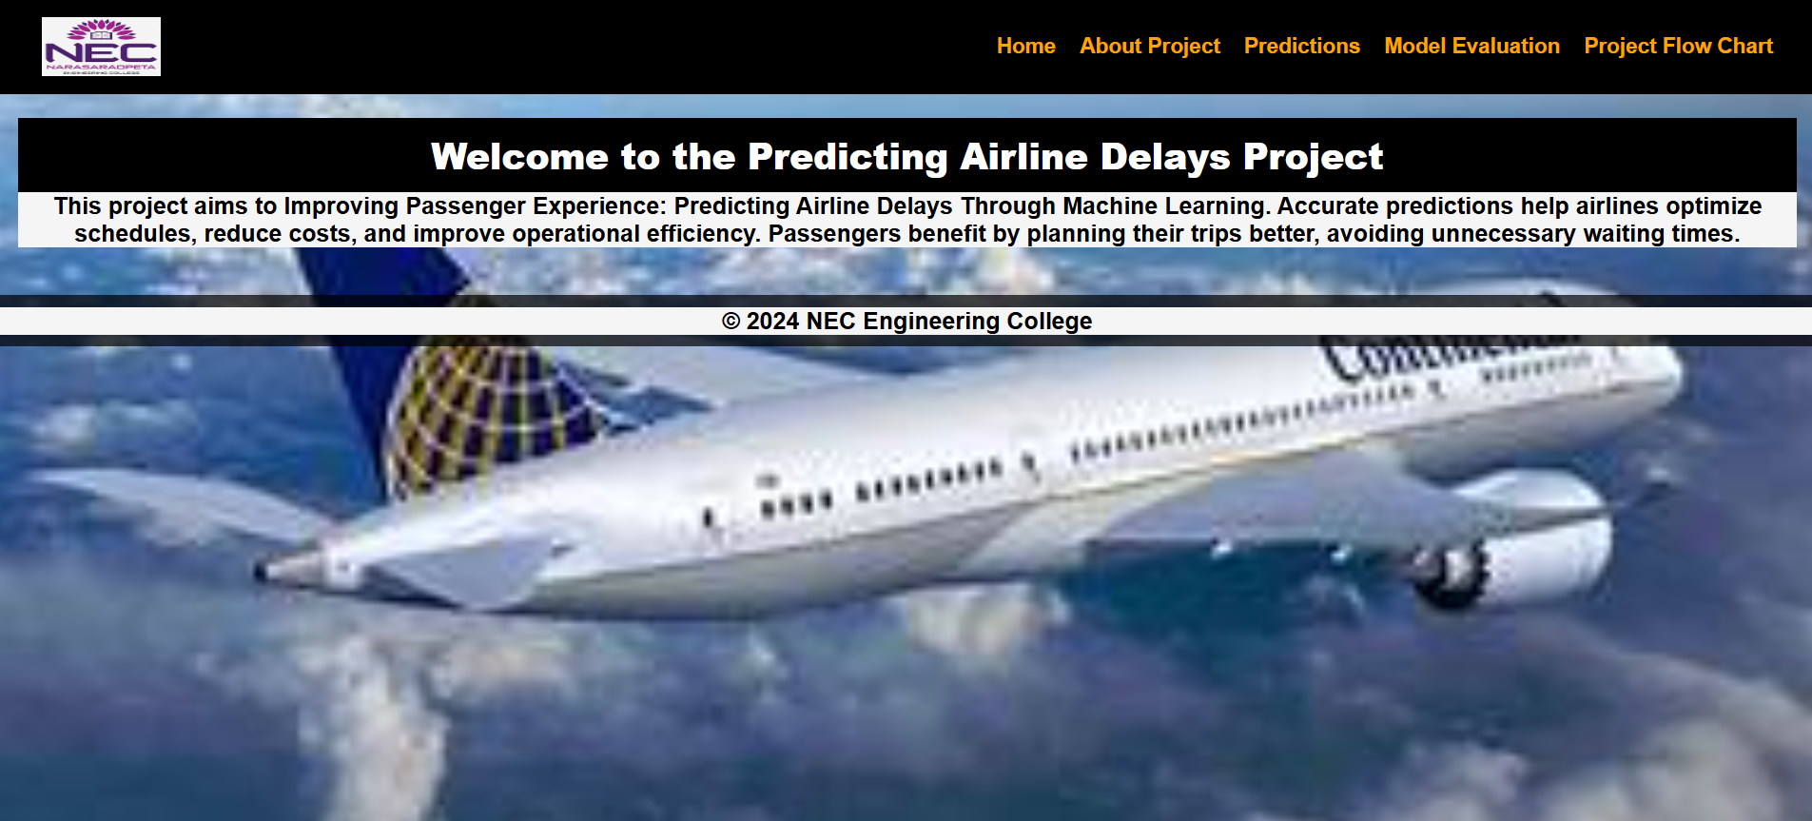

**Fig. 8.1:** Home Screen

The webpage banner is project titled "Predicting Airline Delays Project." focuses on improving passenger experience using machine learning to predict airline delays. The goal is to help airlines optimize schedules, reduce costs, and improve operational efficiency, ultimately benefiting passengers by minimizing waiting times.

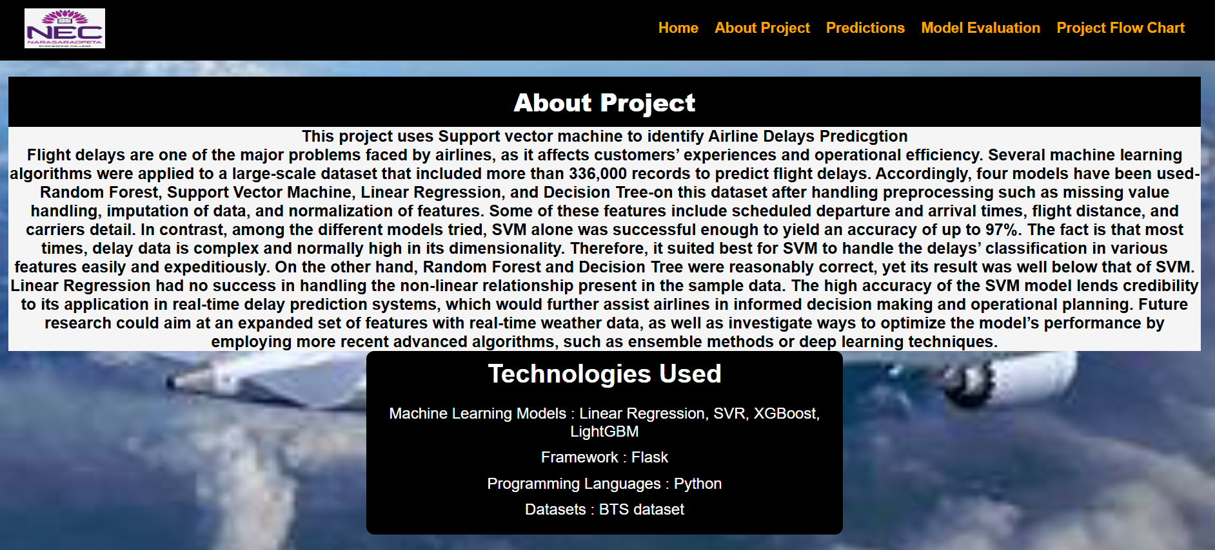

**Fig .8.2:** About Project Page

The webpage provides details about a project using machine learning to predict airline delays. It highlights the use of support vector machine, which achieved 97% accuracy, outperforming other models like random forest, decision tree, and linear regression. The project employs Flask, Python, and the BTS dataset, aiming to enhance real-time delay predictions.

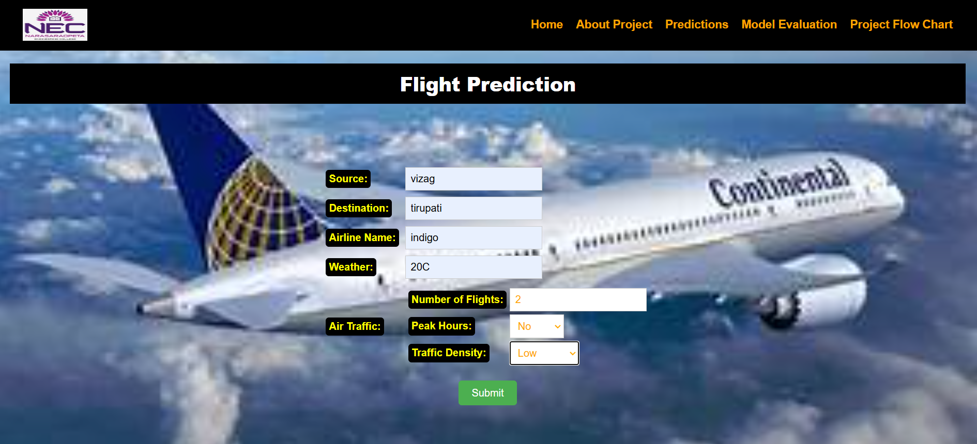

**Fig .8.3:** Delay Prediction page

The webpage shows a flight prediction form where users input details such as source, destination, airline, weather, and traffic conditions. The form includes options like the number of flights, peak hours, and traffic density to predict delays. A submit button is provided to process the input data.

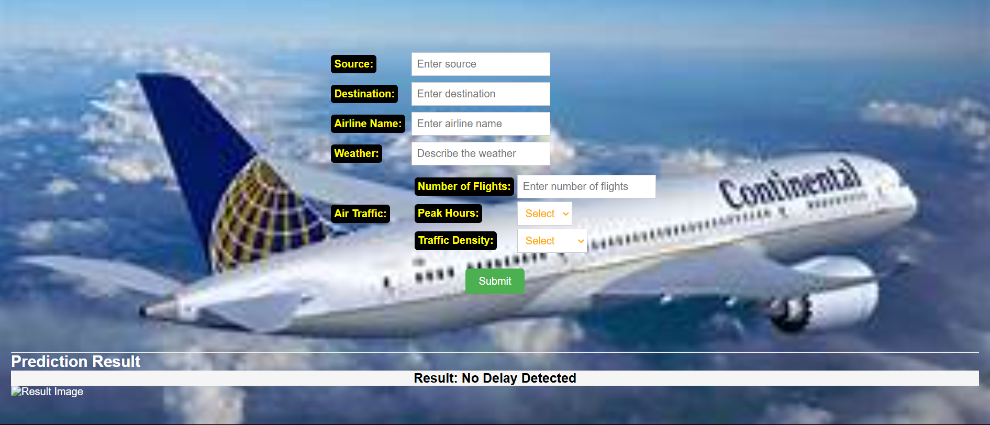

**Fig.8.4:** Result page

This webpage shows the result wheather the flight delay or not delay.

# 

**Fig.8.5:** Model Evaluation Metrics page

The image displays a model evaluation table comparing different machine learning models based on accuracy. SVM has the highest accuracy at 97%, while the decision tree has the lowest at 81.5%.

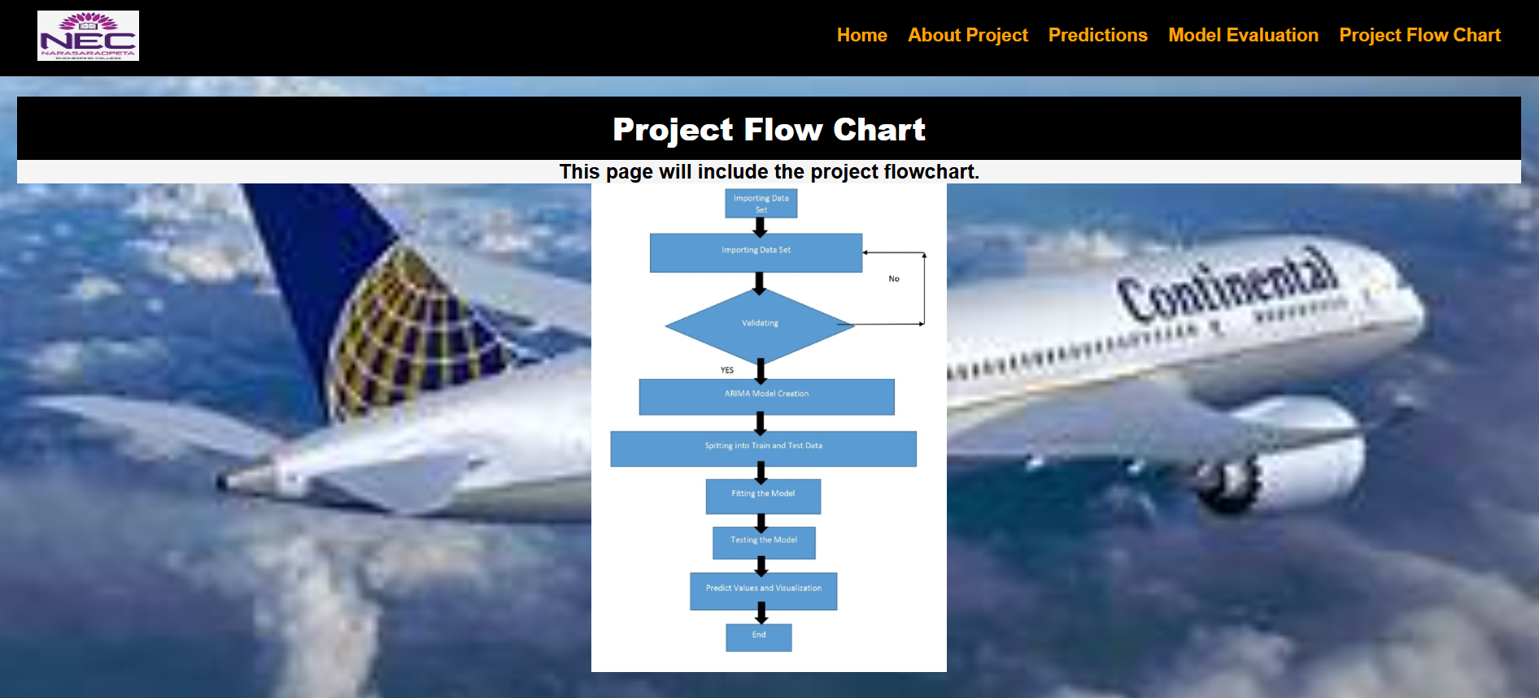

**Fig. 8.6:** Model Flowchart page

The image represents a flowchart for an ARIMA model process, starting from importing and validating the dataset. If validation is successful, the data is split into training and testing sets, followed by model fitting and testing. Finally, the model predicts values and visualizes the results before completion.

# **9. RESULT ANALYSIS**

The study evaluates multiple machine learning models for airline delay prediction, emphasizing the role of data preprocessing and the balance between training and testing accuracy. Handling missing values, feature scaling, and data imputation significantly improve model accuracy, with Support Vector Machine (SVM) achieving the highest accuracy of 97%, demonstrating its robustness in handling high-dimensional and complex datasets. Among the models tested, SVM outperforms others, making it the most suitable for delay prediction, while Random Forest and Decision Tree perform reasonably well but fall short in comparison. Logistic Regression and Neural Networks (MLP) also achieve high accuracy, making them viable alternatives. The comparison of training and testing accuracy highlights that SVM and Logistic Regression exhibit more balanced performance, indicating better generalization to unseen data, whereas Decision Tree and Random Forest show slightly lower generalization, suggesting the need for further feature tuning. Overall, SVM emerges as the best model due to its ability to handle complex data patterns with high accuracy. The study underscores the importance of data preprocessing in enhancing model performance and reliability, while also highlighting the potential for future improvements through real-time data integration and advanced deep learning techniques to further optimize predictions.

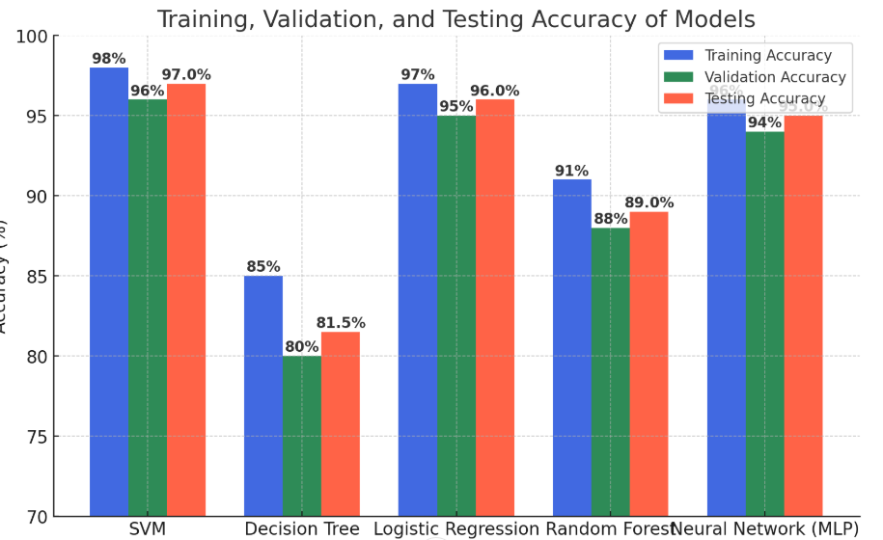

**Fig.9.1.** Trining and Testing accuracy before and after outlier removal

This grpah shows that all model trining and testing , validation accuracy’s among the all models Support vector machine model shows highest acccuracy.

|  |  |  |  |  |
| --- | --- | --- | --- | --- |
| **Model** | **Precision** | **Recall** | **F1-score** | **Accuracy** |
| SVM | 0.9713 | 0.9743 | 0.9890 | 0.9743 |
| Decision Tree | 0.8143 | 0.8356 | 0.7909 | 0.7953 |
| Logistic Regression | 0.9624 | 0.955 | 0.967 | 0.981 |
| Random Forest | 0.8955 | 0.925 | 0.899 | 0.766 |
| NN(MLP) | 0.9555 | 0.9456 | 0.9765 | 0.9501 |

**Fig 9.2:** Comparision of Precision, Recall, F1-score among models

The evaluation of different machine learning models highlights their performance in terms of precision, recall, F1-score, and accuracy. SVM achieves the highest accuracy of 97.43% with strong precision and recall, making it the most reliable model for predictions. Logistic Regression follows closely with 98.1% accuracy and a well-balanced F1-score of 0.967, proving its effectiveness in classification tasks. The Neural Network (MLP) also demonstrates high performance with a 95.01% accuracy and an F1-score of 0.9765, indicating its robustness in learning complex patterns. Random Forest, while maintaining a decent precision of 0.8955, has the lowest accuracy at 76.6%, suggesting its struggle with generalization. The Decision Tree model shows moderate results, with an accuracy of 79.53% and an F1-score of 0.7909, highlighting its tendency to overfit. SVM and Logistic Regression outperform other models in terms of generalization and balanced performance. Neural Network (MLP) exhibits strong predictive capability but slightly lower recall than SVM. Random Forest achieves good recall but lower accuracy, indicating possible misclassifications. Decision Tree's relatively lower scores suggest it may not be the best choice for high-precision applications. Overall, SVM and Logistic Regression emerge as the most effective models for accurate and reliable classification.

**10. CONCLUSION**

The implementation of machine learning models to predict airline delays has shown promising results, demonstrating the potential of artificial intelligence in enhancing aviation efficiency. The Support Vector Machine (SVM) model emerged as the most effective in handling complex datasets, achieving an impressive accuracy of 97%. This high performance is attributed to the model’s ability to handle non-linear relationships and classify flight delays effectively. By incorporating critical features such as scheduled departure and arrival times, flight distances, and airline details, the study successfully identified key variables contributing to delays. These insights can help airlines optimize scheduling and resource allocation, ultimately improving operational efficiency.

The comparative analysis of different machine learning models revealed that while Random Forest and Decision Tree models provided reasonable accuracy, they were less effective than SVM. Linear Regression struggled with the dataset’s complexity, indicating its limitations in capturing intricate delay patterns. The findings emphasize the importance of model selection based on dataset characteristics, as different algorithms respond differently to varying data distributions. The study also highlighted the need for robust preprocessing techniques, such as handling missing values and normalizing features, to ensure optimal model performance. Future improvements can focus on refining these preprocessing steps to further enhance predictive accuracy.

Real-world applications of this research could significantly benefit the aviation industry by enabling proactive measures to mitigate flight delays. By integrating real-time data sources such as weather conditions, air traffic congestion, and aircraft maintenance records, the predictive model can become even more accurate and dynamic. Airlines can use such models to provide passengers with timely updates and better manage ground operations, reducing the impact of delays on overall travel experiences. Additionally, deploying these models on cloud platforms or airport edge computing systems could allow for real-time predictions, offering actionable insights for both airlines and travelers.

Despite the promising results, challenges remain in improving model generalizability and handling unforeseen disruptions in flight schedules. Expanding the dataset to include external factors such as geopolitical events, fuel availability, and airline staffing issues could further enhance the model’s robustness. Additionally, exploring deep learning techniques and ensemble methods might yield even greater accuracy in delay prediction. Ensuring the model’s adaptability to various regions and airline networks will be crucial for large-scale implementation. By addressing these challenges, the predictive framework can evolve into a comprehensive decision-support system for the aviation sector.

In conclusion, the study underscores the transformative role of machine learning in predicting airline delays with high accuracy. The superior performance of the SVM model establishes it as a viable solution for real-time delay prediction, which can drive operational improvements and enhance passenger experiences. As the aviation industry continues to evolve, integrating advanced predictive analytics with real-time data streams will be key to minimizing disruptions and optimizing airline operations. Future research should focus on refining feature selection, incorporating deep learning techniques, and expanding datasets to create even more precise and adaptive models. By doing so, the potential of artificial intelligence in revolutionizing air travel can be fully realized.

# **11. FUTURE SCOPE**

The future of airline delay prediction using machine learning lies in integrating real-time data sources such as weather conditions, air traffic congestion, and airport operations. By incorporating live feeds from aviation authorities and meteorological services, models can adapt dynamically to changing conditions, improving accuracy and reliability. Future advancements may also include the use of IoT sensors on aircraft and runways to collect granular data on delays, enhancing predictive capabilities. Additionally, the adoption of federated learning can allow multiple airlines to collaborate on model training without sharing sensitive data. This approach will lead to more personalized and efficient flight delay predictions, benefiting passengers and airline operations alike.

Deep learning techniques, such as recurrent neural networks (RNNs) and transformer models, hold promise for improving delay predictions by capturing complex temporal patterns in flight data. Unlike traditional machine learning models, these approaches can analyze sequential data like flight schedules, historical delays, and route congestion more effectively. By leveraging attention mechanisms, models can prioritize important factors influencing delays, leading to more accurate predictions. Future research may focus on hybrid models combining deep learning with classical machine learning to enhance both interpretability and performance. Such innovations will enable airlines to implement smarter scheduling strategies and reduce operational disruptions.

The deployment of cloud-based predictive systems will revolutionize delay forecasting by providing scalable and high-performance computing resources. Cloud infrastructure will enable real-time model updates, ensuring that predictions remain relevant as new data becomes available. Additionally, APIs can be developed for airlines and passengers to access delay predictions on mobile applications, improving transparency and travel planning. Future improvements may involve integrating these predictive systems with airline customer service platforms, allowing proactive communication with passengers about potential delays. This advancement will enhance passenger experience and streamline airline operations, reducing economic losses due to flight disruptions.

The future scope of airline delay prediction extends to optimizing airport logistics and resource management. By integrating predictive models with airport management systems, ground crew and air traffic controllers can make informed decisions about gate assignments, baggage handling, and crew scheduling. Predictive analytics will help airports allocate resources efficiently, minimizing turnaround times and preventing cascading delays. Future developments may also incorporate reinforcement learning techniques, where models learn optimal strategies through continuous feedback. This approach can improve overall operational efficiency, reducing congestion at major hubs and enhancing on-time performance.

Expanding the dataset used for delay prediction can lead to more robust and generalized models. Future research can explore additional variables such as passenger load factors, aircraft maintenance records, and fuel efficiency metrics. By considering a broader range of features, machine learning models can provide a more comprehensive understanding of delay patterns. Furthermore, collaboration between airlines and regulatory authorities can facilitate data sharing for improved model training. The integration of blockchain technology may also enhance data security and transparency, ensuring the reliability of shared aviation data.

Future advancements in explainable AI (XAI) will enhance trust and adoption of machine learning-based delay predictions. Airlines and regulatory bodies require interpretable models to understand the factors contributing to delays and take appropriate corrective actions. Techniques such as SHAP (Shapley Additive Explanations) and LIME (Local Interpretable Model-Agnostic Explanations) can provide insights into model decisions, ensuring accountability. Additionally, AI-driven simulation tools may be developed to test different operational scenarios and assess their impact on delays. This will allow airlines to refine their strategies for mitigating disruptions and improving overall service reliability.

**12. REFERENCES**

[1] Lapamonpinyo, P., Derrible, S., Corman, F. (2022). Real-time passenger train delay prediction using machine learning: A case study with amtrak passenger train routes. IEEE Open Journal of Intelligent Transportation Systems, 3, 539-550.

[2] Bisandu, D. B., Moulitsas, I. (2024). Prediction of flight delay using deep operator network with gradient-mayfly optimisation algorithm. Expert Systems with Applications, 247, 123306.

[3] Zhang, D., Peng, Y., Zhang, Y., Wu, D., Wang, H., Zhang, H. (2021). TrainTime delay prediction for high-speed train dispatching based on spatio-temporal graph convolutional network. IEEE Transactions on Intelligent Transportation Systems, 23(3), 2434-2444.

[4] Lykou, G., Dedousis, P., Stergiopoulos, G., Gritzalis, D. (2020). Assessing interdependencies and congestion delays in the aviation network. Ieee Access, 8, 223234-223254.

[5] Zhang, H., Liang, S., Han, Y., Ma, M., Leng, R. (2020). A prediction model for bus arrival time at bus stop considering signal control and surrounding flow. IEEE Access,8,127672-127681.

[6] Pineda-Jaramillo, J., Bigi, F., Bosi, T., Viti, F., D’ariano, A. (2023). Short-term arrival delay time prediction in freight rail operations using data-driven models. IEEE Access, 11, 46966-46978.

[7] Boateng, V. A., Yang, B. (2023). A global modeling pruning ensemble stacking with deep learning and neural network meta-learner for passenger train delay prediction. IEEE Access, 11, 62605-62615.

[8] Guleria, Y., Cai, Q., Alam, S., Li, L. (2019). A multi-agent approach for reactionary delay prediction of flights. IEEE Access, 7, 181565-181579.

[9] Kan, H. Y., Wong, D., Chau, K. (2024). A Personalized Flight Recommender System Based on Link Prediction in Aviation Data. IEEE Access.

[10] Kothari, R., Kakkar, R., Agrawal, S., Oza, P., Tanwar, S., Jayaswal, B.,... Bokoro, P. N. (2023). Selection of best machine learning model to predict delayin passenger airlines.